

GR22 Regulations

II B. Tech - II Semester

Full Stack Web Development Lab (GR22A2078)

Department of Computer Science and Engineering

**SYLLABUS**

**Gokaraju Rangaraju Institute of Engineering and Technology**

# Full Stack Web Development Lab

**Course Code: GR22A2078 L/T/P/C: 0/0/3/1.5**

# II Year II Semester

# Prerequisites: Knowledge of object-oriented programming concepts

## Course Objectives:

1. To understand designing of Front-End Applications.
2. To design client-side applications using HTML, JavaScript.
3. To build robust and scalable websites, backend APIs.
4. To understand end-to-end application with exciting features and test it.
5. To understand database connectivity with web applications.

## Course Outcomes:

1. To design a website
2. To implement client-side validation.
3. To develop the robust and scalable websites, backend APIs
4. To implement end-to-end applications.
5. To design web applications with database connectivity.

**TASK 1**: Develop a website by implementing JavaScript functions for the following problems:

Parameter: A string

**Output:** The position in the string of the left-most vowel Parameter: A number

**Output:** The number with its digits in the reverse order

**TASK 2:** Write a JavaScript program to calculate the squares and cubes of the numbers from 0 to 10 and outputs HTML text that displays the resulting values in an HTML table format.

**TASK 3:** Write a JavaScript program to display text “TEXT-GROWING” with increasing font size in the interval of 100ms in RED COLOR, when the font size reaches 50pt it displays “TEXTSHRINKING”in BLUE color. Then the font size decreases to 5pt.

**TASK 4:** Write a JavaScript program to design a simple calculator to perform the following operations: sum, product, difference and quotient.

**TASK 5:** Write a JQuery AJAX program to request data from the server with an HTTP.

**TASK 6:** Create following Student Information form with submit and reset functionality using Angular JS.

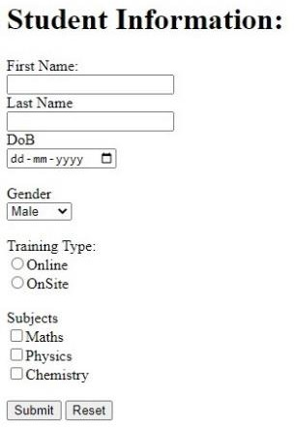

Sample AngularJS Form.

**TASK 7:** Use AngularJS features to make a shopping list, where you can add or remove items as shown below.

My Shopping List Milk×



Bread× Cheese×

Add

**TASK 8:** Write a Servlet Program that accepts the Mobile phone details from user and displays the details on the next page. Create a table and perform insert operation as shown in the Figure 1 below.Connect using JDBC to display each record at a time on the webpage using servlet request and response.

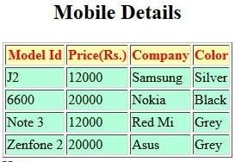

Figure 1: Table Details

**TASK 9:** Develop a JSP Program to validate a particular user login based on the username password stored in the database and display a welcome page.

**TASK 10:** Write PHP programs to do the following tasks:

1. Implement simple calculator operations.
2. Find the transpose of a matrix.
3. Multiplication of two matrices.
4. Addition of two matrices.

**TASK 11:** Write a PHP program named states.py that declares a variable states with value "Mississippi Alabama Texas Massachusetts Kansas". Write a PHP program that does the following:

1. Search for a word in variable states that ends in xas. Store this word in element 0 of a list named statesList.
2. Search for a word in states that begins with k and ends in s. Perform a case insensitive comparison.

[Note: Passing re.Ias a second parameter to method compile performs a case-insensitive comparison.] Store this word in element1 of states List.

1. Search for a word in states that begins with M and ends in s. Store this word in element 2 of the list.
2. Search for a word in states that ends in a. Store this word in element 3 of the list.

**TASK 12:** Write a PHP program to sort the student records which are stored in the database using selection sort.

## Textbooks:

1. Modern Full-Stack Development: Using TypeScript, React, Node.js, Webpack, and Docker 1st ed. Edition by Frank Zammetti
2. Web Design with HTML, CSS, JavaScript and jQuery Set 1st Edition by Jon Duckett
3. The Full Stack Developer: Your Essential Guide to the Everyday Skills Expected of a Modern

Full Stack Web Developer 1st ed. Edition, Kindle Edition by Chris Northwood

## References:

1. Quick Start Full Stack Web Development: Build Secure Asynchronous Single-Page Apps with

Flask, React, and PostgreSQL by Erik M. Ferragut (Author)

1. Full Stack Web Development For Beginners: Learn Ecommerce Web Development Using HTML5, CSS3,
2. Bootstrap, JavaScript, MySQL, and PHP by Riaz Ahmed.

# INDEX

|  |  |  |  |
| --- | --- | --- | --- |
| **S.No** | **Task No** | **Name of the Task** | **Page No.** |
| 1 | Task 1a | Develop a website by implementing JavaScript functions for the following problems:  **a:** Parameter: A string | 1 |
| 2 | Task 1b | Develop a website by implementing JavaScript functions for the following problems:  **b:** Parameter: A number | 2 |
| 3 | Task 2 | Write a JavaScript program to calculate the squares and cubes of the numbers from 0 to 10  and outputs HTML text that displays the resulting values in an HTML table format. | 3 |
| 4 | Task 3 | Write a JavaScript program to display text “TEXT-  GROWING” with increasing font size  in the interval of 100ms in RED COLOR, when the font size reaches 50pt it displays “TEXTSHRINKING”  in BLUE color. Then the font size decreases to 5pt. | 4 |
| 5 | Task 4 | Write a JavaScript program to design a simple calculator to perform the following  operations: sum, product, difference and quotient | 6 |
| 6 | Task 5 | Write a JQuery AJAX program to request data from the server with an HTTP. | 11 |
| 7 | Task 6 | Create following Student Information form with submit and reset functionality using  Angular JS. | 13 |
| 8 | Task 7 | Use AngularJS features to make a shopping list, where you can add or remove items | 16 |
| 9 | Task 8 | Write a Servlet Program that accepts the Mobile phone details from user and displays the  details on the next page. Create a table and perform insert operation as shown in the Figure 1 below.  Connect using JDBC to display each record at a time on the webpage using servlet request and  response. | 18 |
| 10 | Task 9 | Develop a JSP Program to validate a particular user login based on the username password  stored in the database and display a welcome page. | 22 |

|  |  |  |  |
| --- | --- | --- | --- |
| **S.No** | **Task No** | **Name of the Task** | **Page No.** |
| 11 | Task 10 | Write PHP programs to do the following tasks:   1. Implement simple calculator operations. 2. Find the transpose of a matrix. 3. Multiplication of two matrices. 4. Addition of two matrices. | 24 |
| 12 | Task 11 | Write a PHP program named states.py that declares a variable states with value"Mississippi Alabama Texas Massachusetts Kansas". Write a PHP program that does the following:   1. Search for a word in variable states that ends in xas.   Store this word in element 0 of a list named states List.   1. Search for a word in states that begins with k and ends in s. Perform a case insensitive comparison. [Note: Passing re.Ias a second parameter to method compile performs a case-insensitive comparison.] Store this word in element1 of statesList. 2. Search for a word in states that begins with M and ends in s. Store this word in element 2 of the list. 3. Search for a word in states that ends in a. Store this word in element 3 of the list. | 26 |
| 13 | Task 12 | Write a PHP program to sort the student records which are stored in the database using selection sort. | 28 |

**TASK 1**

**TASK 1a:** Develop a website by implementing JavaScript functions for the following problems:

**a:** Parameter: A string

**AIM:** To develop a website by implementing JavaScript functions with output as the position in the string of the left-most vowel.

**PROGRAM:**

<!DOCTYPE HTML>

<html>

<head>

<script type ="text/javascript">

function str_vowel()

{

var str=prompt("Enter a string\n","");

for(var i = 0; i<str.length; i++)

{

if (str.charAt(i) =='a' || str.charAt(i) == 'e' || str.charAt(i) =='i'

|| str.charAt(i) == 'o' || str.charAt(i) == 'u' || str.charAt(i) == 'A' ||

str.charAt(i) == 'E' || str.charAt(i) =='I' || str.charAt(i) =='O' || str.charAt(i) == 'U')

{

document.write("The entered string is:" +str+ "<br/>");

document.write("The leftmost vowel is :"+str.charAt(i)+"<br/>");

var pos = i+1;

document.write("The position of the leftmost vowel " +str.charAt(i)+ " is:" +pos+"\n");

exit;

}

}

document.write("The entered string is:" +str+ "<br/>");

document.write("The entered string has no vowels");

}

</script>

</head>

<body onload="str_vowel()">

</body>

</html>

**OUTPUT:**

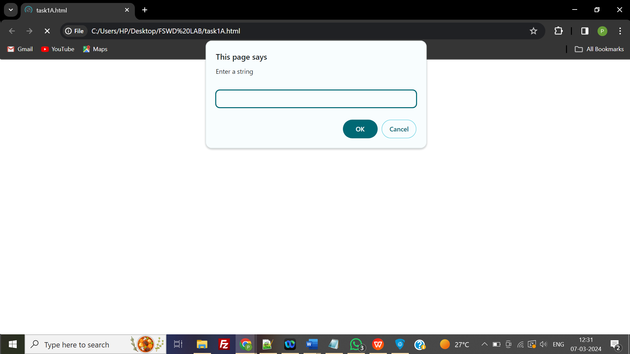

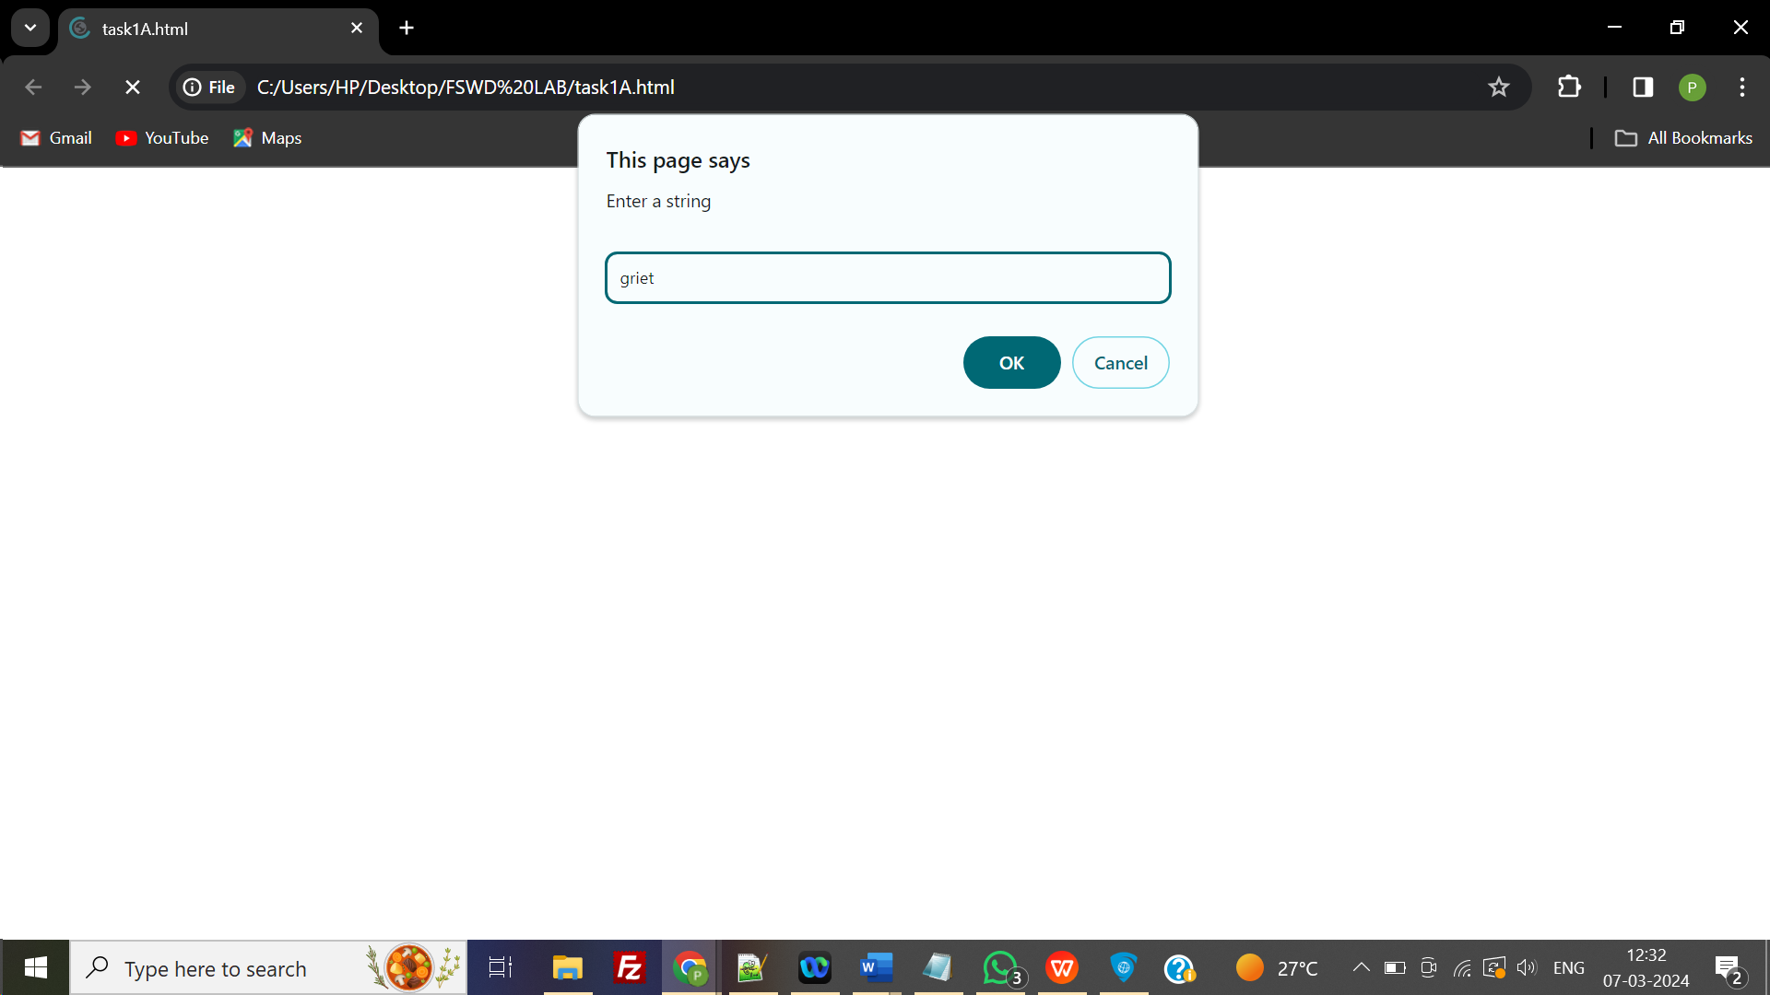

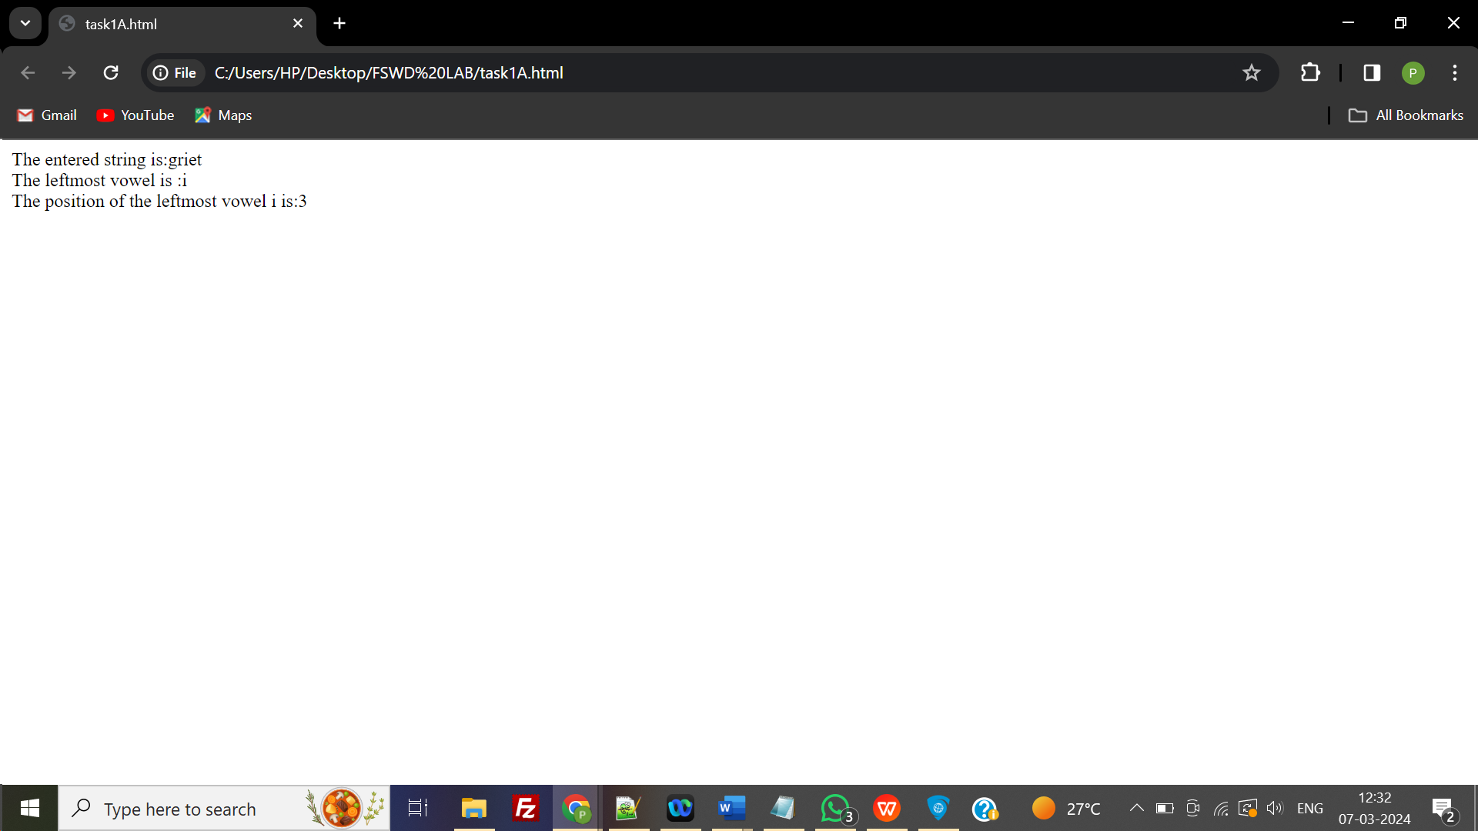

**TASK 1b:** Develop a website by implementing JavaScript functions for the following problems:

**b:** Parameter: A number

**AIM:** To develop a website by implementing JavaScript functions with output the number digits in the reverse order

**PROGRAM:**

<!DOCTYPE html>

<html>

<body>

<script>

function reverse() {

var r,rev=0,n;

n = parseInt(prompt("enter a number:"));

while (n != 0) {

r = n % 10;

rev = rev * 10 + r;

n = parseInt(n / 10);

}

document.write("reverse of number is:"+rev);

}

</script>

<form>

<input type="button" value="reverse" onclick="reverse();" />

</form>

</body>

</html>

**OUTPUT:**

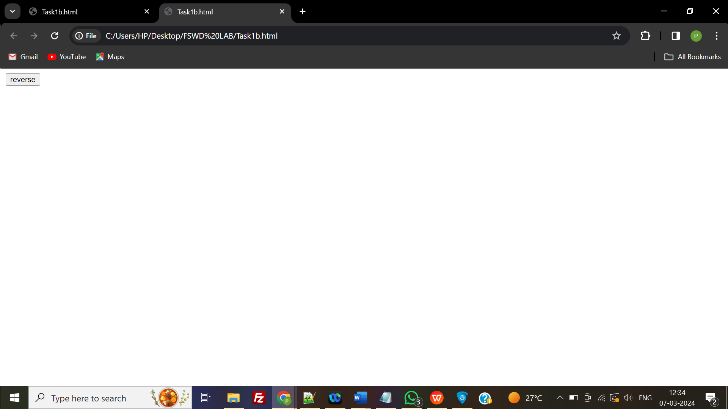

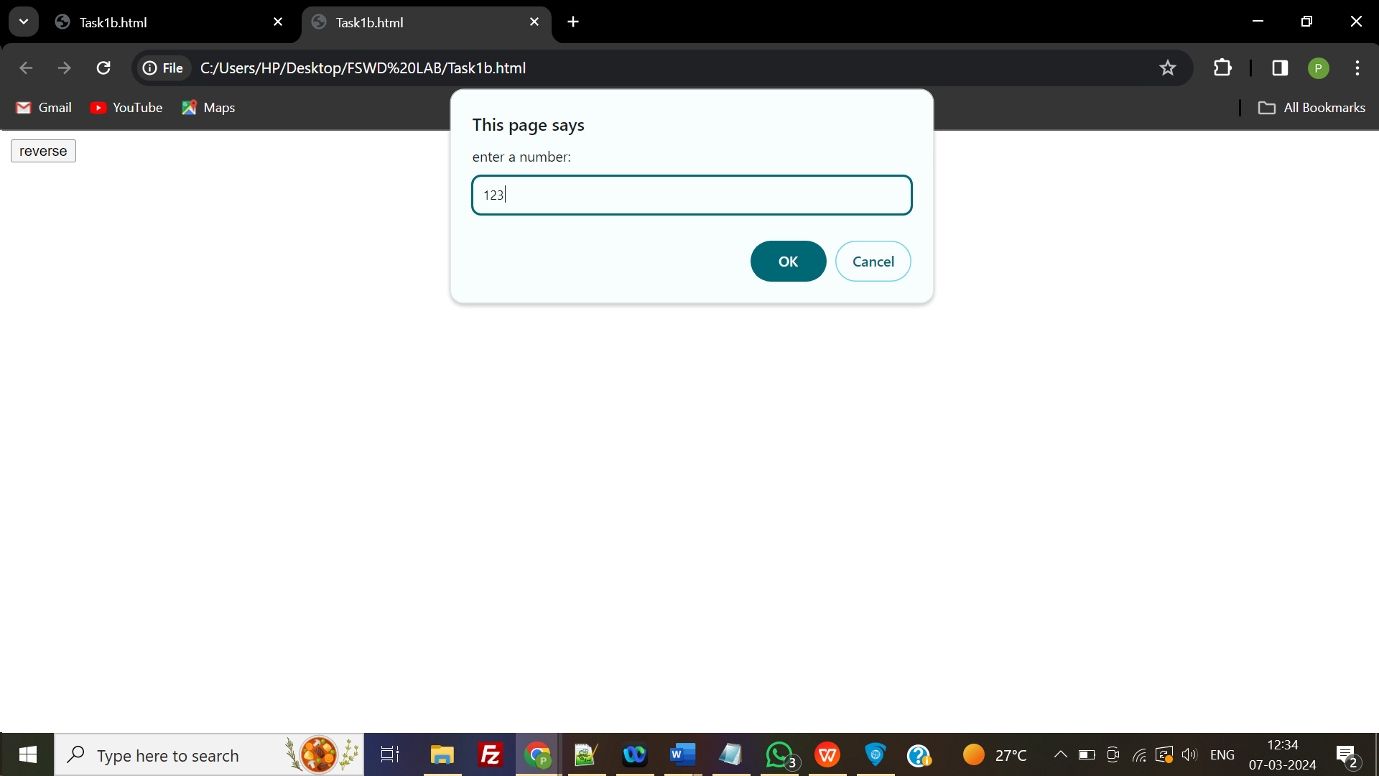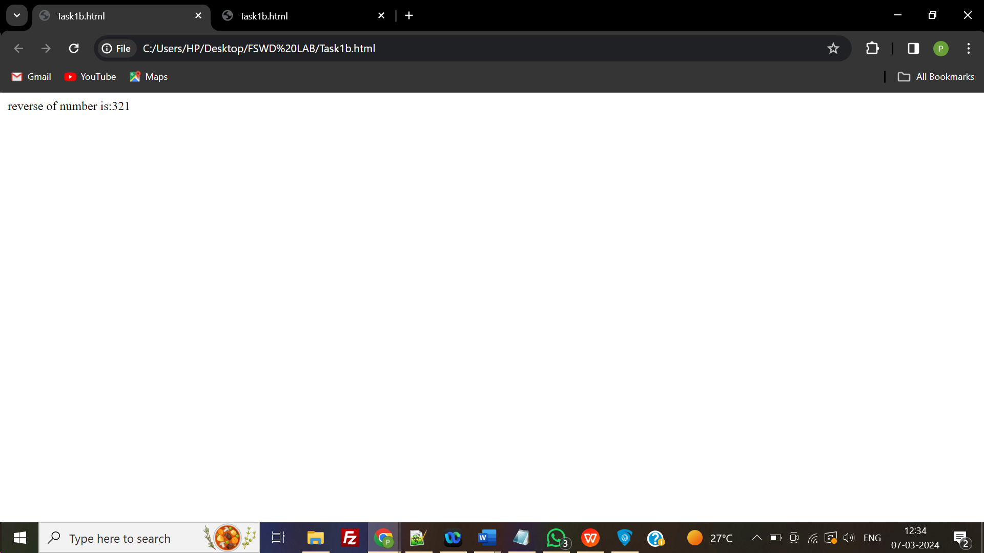

# TASK 2

**TASK 2:** Write a JavaScript program to calculate the squares and cubes of the numbers from 0 to 10 and outputs HTML text that displays the resulting values in an HTML table format.

**AIM:** To develop a JavaScript program to calculate the squares and cubes of the numbers.

**PROGRAM:**

<html>

<head>

</head>

<body>

<h2 style="text-align:center;"> The Square & Cubes for 1 -10</h2>

<table align="center" border=1>

<tr><td>number</td><td>square</td><td>cube</td></tr>

<script type="text/javascript"> for(var n=0; n<=10; n++)

{

document.write( "<tr><td>" + n + "</td><td>" + n*n + "</td><td>" + n*n*n+ "</td></tr>" ) ;

}

</script>

</table>

</body>

</html>

**OUTPUT:**

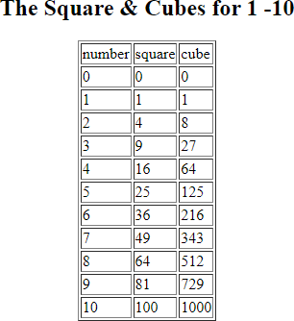

# TASK 3

**TASK 3:** Write a JavaScript program to display text “TEXT-GROWING” with increasing font size in the interval of 100ms in RED COLOR, when the font size reaches 50pt it displays “TEXTSHRINKING” in BLUE color. Then the font size decreases to 5pt.

**AIM:** To write a JavaScript program to display text “TEXT-GROWING” with increasing with font in RED COLOR and “TEXTSHRINKING” in BLUE color

**PROGRAM:**

<!DOCTYPE html>

<html>

<body>

<div id="h"></div>

<script>

var v = 0, f = 1,t="TEXT-GROWING",color; function a()

{

if(f==1) v+=5,color="red"; else

v-=5,color="blue";

document.getElementById("h").innerHTML = "<h1 style=\"font-size: "+v+"px ; margin:0px; color : "+color+"\"><b> "+t+"</b></h1>";

if(v==50)

f = 0, t="TEXT-SHRINKING";

if(v==5)

f = 1, t="TEXT-GROWING"; c();

}

function c()

{

setTimeout(a,100);

} c();

</script>

</body>

</html>

**OUTPUT:**

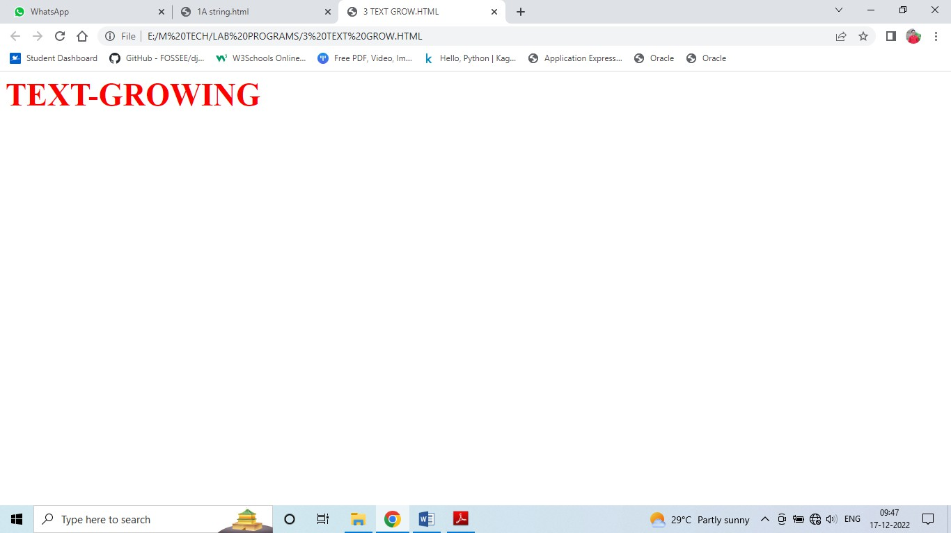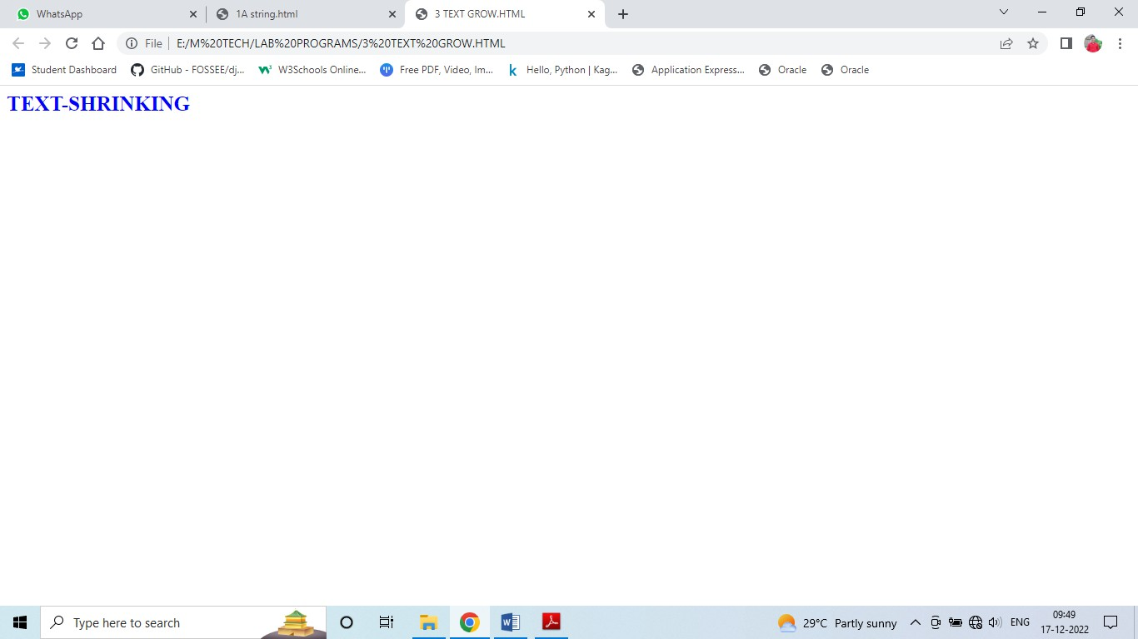

# TASK 4

**TASK 4:** Write a JavaScript program to design a simple calculator to perform the following operations: sum, product, difference and quotient.

**AIM:** To design a simple calculator to perform sum, product, difference and quotient operations.

**PROGRAM:**

<!DOCTYPE html>

<html lang = "en">

<head>

<title> JavaScript Calculator </title>

<style>

h1 {

text-align: center; padding: 23px;

background-color: skyblue; color: white;

}

#clear{ width: 270px;

border: 3px solid gray; border-radius: 3px; padding: 20px; background-color: red;

}

.formstyle

{

width: 300px; height: 530px; margin: auto;

border: 3px solid skyblue; border-radius: 5px; padding: 20px;

}

input

{

width: 20px;

background-color: green; color: white;

border: 3px solid gray; border-radius: 5px; padding: 26px; margin: 5px;

font-size: 15px;

}

#calc{

width: 250px;

border: 5px solid black; border-radius: 3px; padding: 20px; margin: auto;

}

</style>

</head>

<body>

<h1> Calculator Program in JavaScript </h1>

<div class= "formstyle">

<form name = "form1">

<!-- This input box shows the button pressed by the user in calculator. -->

<input id = "calc" type ="text" name = "answer"> <br> <br>

<!-- Display the calculator button on the screen. -->

<!-- onclick() function display the number prsses by the user. -->

<input type = "button" value = "1" onclick = "form1.answer.value += '1' ">

<input type = "button" value = "2" onclick = "form1.answer.value += '2' ">

<input type = "button" value = "3" onclick = "form1.answer.value += '3' ">

<input type = "button" value = "+" onclick = "form1.answer.value += '+' ">

<br> <br>

<input type = "button" value = "4" onclick = "form1.answer.value += '4' ">

<input type = "button" value = "5" onclick = "form1.answer.value += '5' ">

<input type = "button" value = "6" onclick = "form1.answer.value += '6' ">

<input type = "button" value = "-" onclick = "form1.answer.value += '-' ">

<br> <br>

<input type = "button" value = "7" onclick = "form1.answer.value += '7' ">

<input type = "button" value = "8" onclick = "form1.answer.value += '8' ">

<input type = "button" value = "9" onclick = "form1.answer.value += '9' ">

<input type = "button" value = "*" onclick = "form1.answer.value += '*' ">

<br> <br>

<input type = "button" value = "/" onclick = "form1.answer.value += '/' ">

<input type = "button" value = "0" onclick = "form1.answer.value += '0' ">

<input type = "button" value = "." onclick = "form1.answer.value += '.' ">

<!-- When we click on the '=' button, the onclick() shows the sum results on the calculator screen. -->

<input type = "button" value = "=" onclick = "form1.answer.value = eval(form1.answer.value) ">

<br>

<!-- Display the Cancel button and erase all data entered by the user. -->

<input type = "button" value = "Clear All" onclick = "form1.answer.value = ' ' " id= "clear"

>

<br>

</form>

</div>

</body>

</html>

**OUTPUT:**

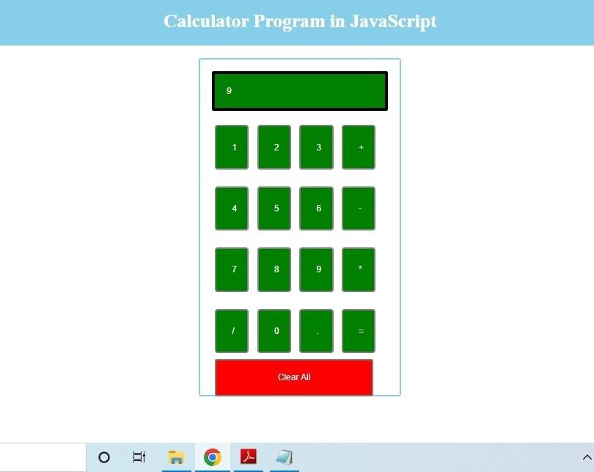

# TASK 5

**TASK 5:** Write a JQuery AJAX program to request data from the server with an HTTP.

**AIM:** To request data from the server with an HTTP using JQuery.

**PROGRAM:**

## Task5.html

<!DOCTYPE html>

<html lang="en">

<head>

<meta charset="utf-8">

<title>jQuery get() Demo</title>

<script src="https://code.jquery.com/jquery-3.5.1.min.js"></script>

<script>

$(document).ready(function(){

$("button").click(function(){

$.get("date-time.php", function(data){

// Display the returned data in browser

$("#result").html(data);

});

});

});

</script>

</head>

<body>

<div id="result">

<h2> The XMLHttpRequest Object by the server date and time</h2>

<button type="button">Load Date and Time</button>

</div>

</body>

</html>

## date-time.php

<?php

// Return current date and time from the server

date_default_timezone_set(“Asia/Kolkata”);

echo date("F d, Y h:i:s A");

?>

**OUTPUT:**

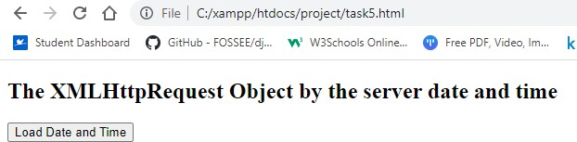

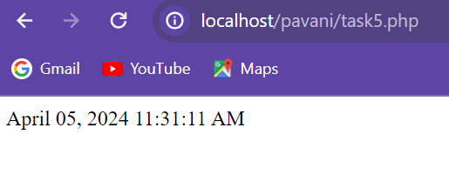

# TASK 6

**TASK 6:** Create following Student Information form with submit and reset functionality using Angular JS..

**AIM:** To Create Student Information form using Angular JS.

**PROGRAM:**

<!DOCTYPE html>

<html lang="en">

<script src="https://ajax.googleapis.com/ajax/libs/angularjs/1.6.9/angular.min.js"></script>

<body>

<h1>student Information</h1>

<div ng-app="myApp" ng-controller="formCtrl">

<form novalidate>

First Name:<br>

<input type="text" ng-model="student.firstName"><br>

Last Name:<br>

<input type="text" ng-model="student.lastName"><br>

DoB:<br>

<input type="date" id="dob" ng-model="student.DoB"><br>

Gender:<br>

<select id="gender" ng-model="student.gender">

<option value="male">Male</option>

<option value="female">Female</option>

</select><br>

Training Type:<br>

<label><input value="online" type="radio" name="training" ng-model="student.trainingType" />Online</label><br>

<label><input value="onsite" type="radio" name="training" ng-model="student.trainingType" />OnSite</label><br>

Subjects:<br>

<label><input type="checkbox" ng-model="student.maths" />Maths</label><br>

<label><input type="checkbox" ng-model="student.physics" />Physics</label><br>

<label><input type="checkbox" ng-model="student.chemistry"/>Chemistry</label><br>

<br><br>

<button type="button" onclick="alert('student saved successfully')">SUBMIT</button>

<button ng-click="reset()">RESET</button>

</form>

<p>form = {{student}}</p>

</div>

<script>

var app = angular.module('myApp', []);

app.controller('formCtrl', function($scope) {

$scope.master = {};

$scope.reset = function() {

$scope.student = angular.copy($scope.master);

};

$scope.reset();

});

</script>

</body>

</html>

**OUTPUT:**

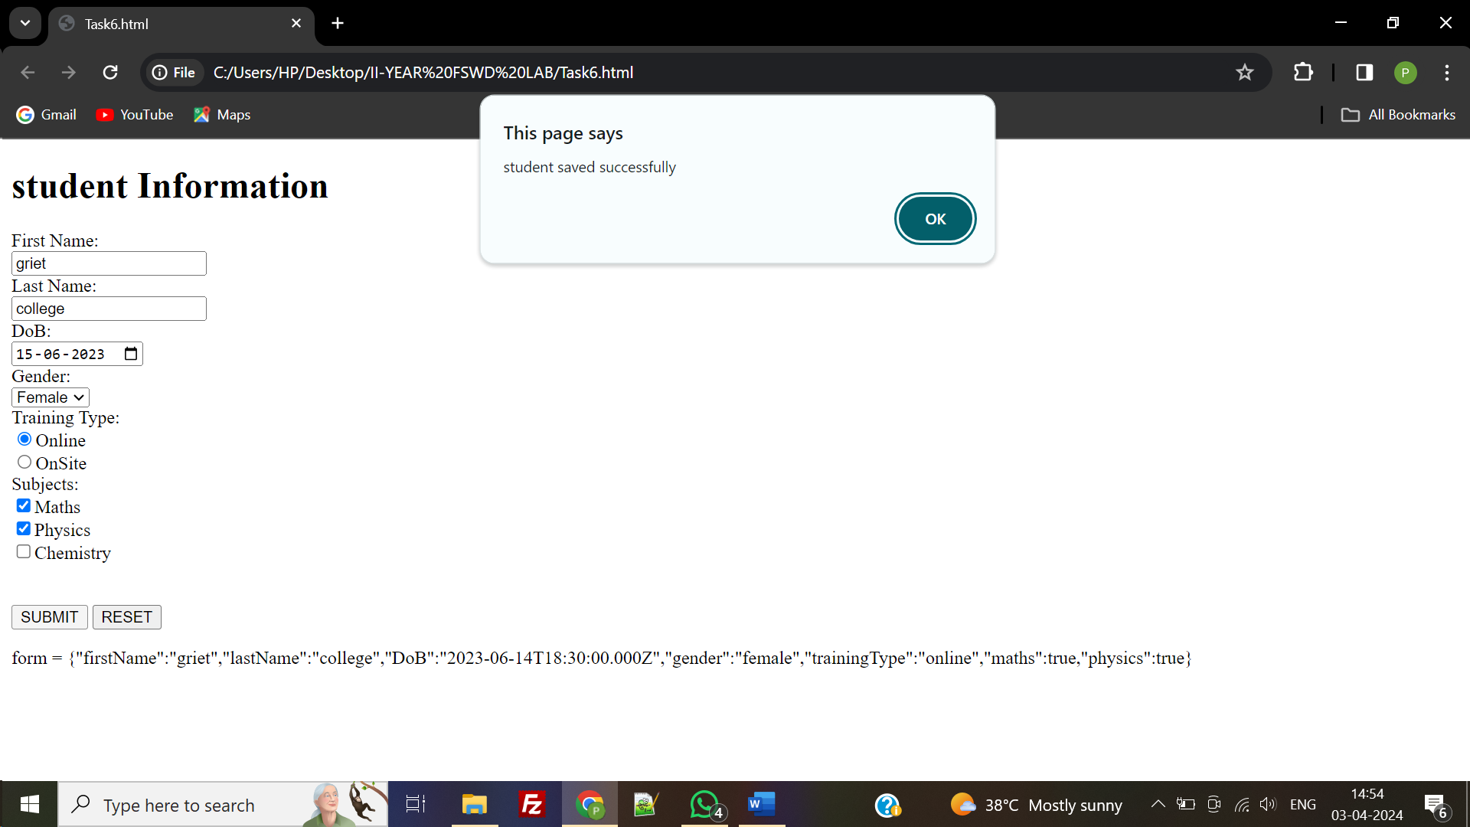

# TASK 7

**TASK 7:** Use AngularJS features to make a shopping list, where you can add or remove items as shown below.

My Shopping List Milk×

Bread× Cheese×

Add TASK

**AIM:** To make a shopping list using Angular JS features where you can add or remove items from cart.

**PROGRAM:**

<!DOCTYPE html>

<html>

<script src="https://ajax.googleapis.com/ajax/libs/angularjs/1.6.9/angular.min.js"></script>

<body>

<script>

var app = angular.module("myShoppingList", []); app.controller("myCtrl", function($scope) {

$scope.products = ["Milk", "Bread", "Cheese"];

$scope.addItem = function () {

$scope.errortext = "";

if (!$scope.addMe) {return;}

if ($scope.products.indexOf($scope.addMe) == -1) {

$scope.products.push($scope.addMe);

} else {

$scope.errortext = "The item is already in your shopping list.";

}

}

$scope.removeItem = function (x) {

$scope.errortext = "";

$scope.products.splice(x, 1);

}

});

</script>

<div ng-app="myShoppingList" ng-controller="myCtrl">

<ul>

<li ng-repeat="x in products">{{x}}<span ng-click="removeItem($index)">×</span></li>

</ul>

<input ng-model="addMe">

<button ng-click="addItem()">Add</button>

<p>{{errortext}}</p>

</div>

<p>Try to add the same item twice, and you will get an error message.</p>

</body>

</html>

**OUTPUT:**

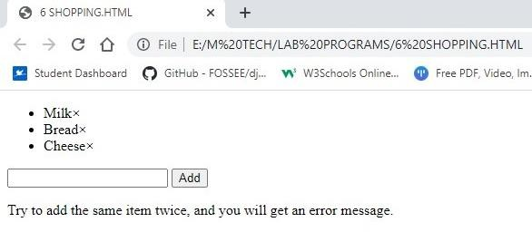

# TASK 8

**TASK 8:** Write a Servlet Program that accepts the Mobile phone details from user and displays the details on the next page. Create a table and perform insert operation as shown in the Figure 1 below. Connect using JDBC to display each record at a time on the webpage using servlet request and response.



Figure 1: Table Details

**AIM:** To write a Servlet Program that accepts the Mobile phone details from user and displays the details on the next page

**PROGRAM:**

## register.html

## <!doctype html>

## <body>

## <form action="/mobile/MobileDetails" method="post">

## <fieldset style="width:25%; background-color:blue">

## <h2 align="center">Mobile Details form</h2><hr>

## <table>

## <tr><td>Model Number</td>

## <td><input type="text" name="ModelId" required /></td></tr>

## <tr><td>Mobile Price</td>

## <td><input type="text" name="Price" required /></td></tr>

## <tr><td>Mobile Company</td>

## <td><input type="text" name="Company" required /></td></tr>

## <tr><td>Mobile Color</td>

## <td><input type="text" name="Color" required/></td></tr>

## <tr><td><input type="reset" value="Reset"/></td>

## <td><input type="submit" value="Register"/></td></tr>

## </table>

## </fieldset>

## </form>

## </body>

## </html>

## Mobiledetails.java

## import java.io.*;

## import java.sql.*;

## import javax.servlet.ServletException;

## import javax.servlet.http.*;

## public class MobileDetails extends HttpServlet

## {

## public void doPost(HttpServletRequest request, HttpServletResponse response) throws

## ServletException, IOException

## {

## response.setContentType("text/html");

## PrintWriter out = response.getWriter();

## System.out.println(request.getParameter("ModelId"));

## String model = request.getParameter("ModelId");

## int price = Integer.parseInt(request.getParameter("Price"));

## String company = request.getParameter("Company");

## String color = request.getParameter("Color");

## try

## {

## //load the driver

## Class.forName("com.mysql.jdbc.Driver");

## //create connection object

## Connection con=DriverManager.getConnection(

## "jdbc:mysql://localhost:3306/mobile","root","");

## //create the prepared statement object

## PreparedStatement ps=con.prepareStatement("insert into MobileDetails values(?,?,?,?)");

## ps.setString(1,model);

## ps.setInt(2,price);

## ps.setString(3,company);

## ps.setString(4, color);

## int i = ps.executeUpdate();

## if(i>0)

## out.print("<font color='green' size='4'>Record inserted successfully...</font>");

## //create the statement object

## Statement stmt = con.createStatement();

## String sql;

## sql = "SELECT * FROM MobileDetails";

## ResultSet rs = stmt.executeQuery(sql);

## out.println("<table border=1 >");

## out.println("<caption><h2>Mobile Details</h2></caption>");

## out.println("<tr style='background-color:#ffffb3; color:red'>");

## out.println("<th>Model Id</th>");

## out.println("<th>Price(Rs.)</th>");

## out.println("<th>Company</th>");

## out.println("<th>Color</th>");

## out.println("</tr>");

## // Extract data from result set

## while(rs.next())

## {

## //Retrieve by column name

## String mModel = rs.getString("ModelId");

## int mPrice = rs.getInt("Price");

## String mCompany = rs.getString("Company");

## String mColor = rs.getString("Color");

## //Display values

## out.println("<tr style='background-color:#b3ffd9;'>");

## out.println("<td>" + mModel + "</td>");

## out.println("<td>" + mPrice + "</td>");

## out.println("<td>" + mCompany + "</td>");

## out.println("<td>" + mColor + "</td>");

## out.println("</tr>");

## }

## out.println("</table>");

## out.println("<a href='register.html'>Home</a>");

## // Clean-up environment

## rs.close();

## stmt.close();

## con.close();

## }

## catch (Exception ex)

## {

## ex.printStackTrace();

## }

## out.close();

## }

## }

## web.xml

<web-app>

<servlet>

<servlet-name>MobileDetails</servlet-name>

<servlet-class>MobileDetails</servlet-class>

</servlet>

<servlet-mapping>

<servlet-name>MobileDetails</servlet-name>

<url-pattern>/servlet/MobileDetails</url-pattern>

</servlet-mapping>

<welcome-file-list>

<welcome-file>register.html</welcome-file>

</welcome-file-list>

</web-app>

**OUTPUT:**

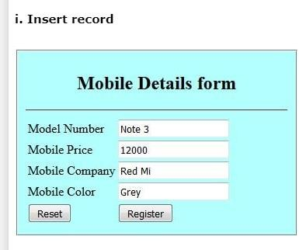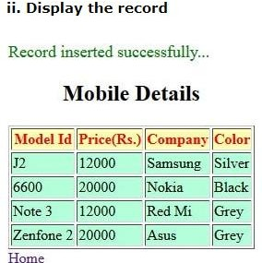

# TASK 9

**TASK 9:** Develop a JSP Program to validate a particular user login based on the username password stored in the database and display a welcome page.

**AIM:** To develop a JSP Program to validate a particular user login based on the username password

**PROGRAM:**

(In NetBeans)

## login.jsp

<%@page contentType="text/html" pageEncoding="UTF-8"%>

<!DOCTYPE html>

<html>

<head>

<meta http-equiv="Content-Type" content="text/html; charset=UTF-8">

<title>LOGIN PAGE</title>

</head>

<body>

<form action="forward.jsp" method="post">

<h1>Enter your Credentials !</h1>

<h3>Username: <input type="text" name = "uname"/></h3>

<h3>Password: <input type="password" name = "pwd"/></h3>

<input type ="submit" value="SUBMIT">

<input type ="reset"/>

</form>

</body>

</html>

## forward.jsp

<%@page contentType="text/html" pageEncoding="UTF-8"%>

<%@page import="java.io.File"%>

<%if(request.getParameter("uname").equals("CSE")&&request.getParameter("pwd").eq uals("griet"))

{%>

<jsp:forward page="welcomePage.jsp"/>

<%} else {%>

<h3>Invalid Username or Password</h3>

<%@include file="login.jsp"%>

<%}%>

## welcomePage.jsp

<%@page contentType="text/html" pageEncoding="UTF-8"%>

<!DOCTYPE html>

<html>

<head>

<meta http-equiv="Content-Type" content="text/html; charset=UTF-8">

<title>WelcomePage</title>

</head>

<body>

<h1>Welcome to<%=request.getParameter("uname")%></h1>

</body>

</html>

**OUTPUT:**

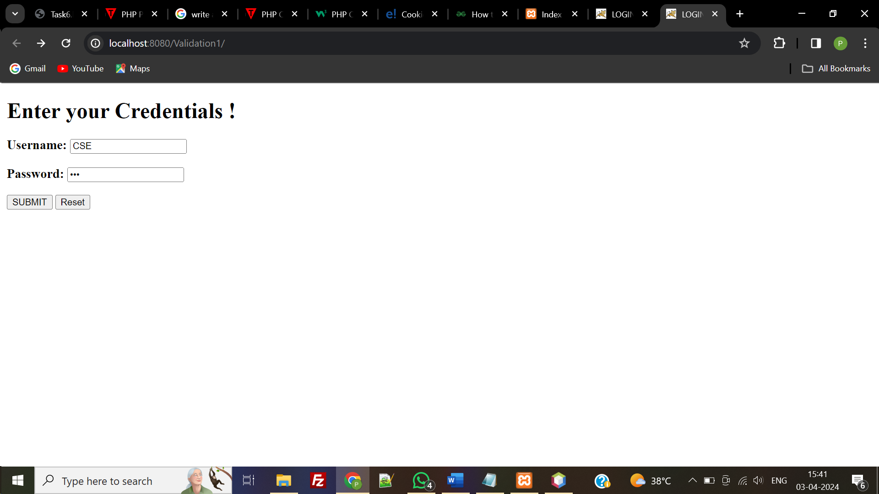

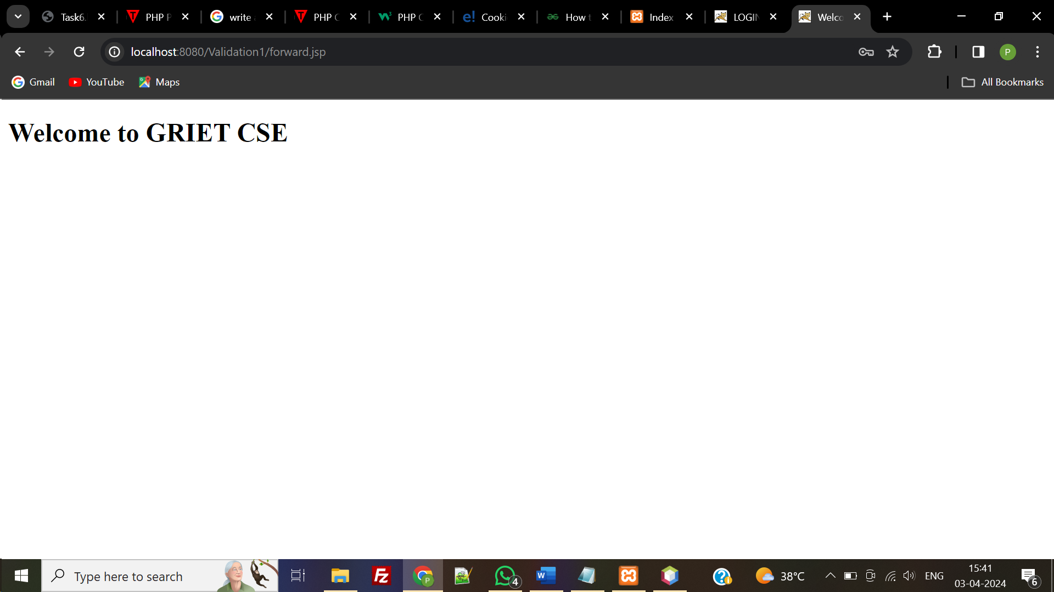

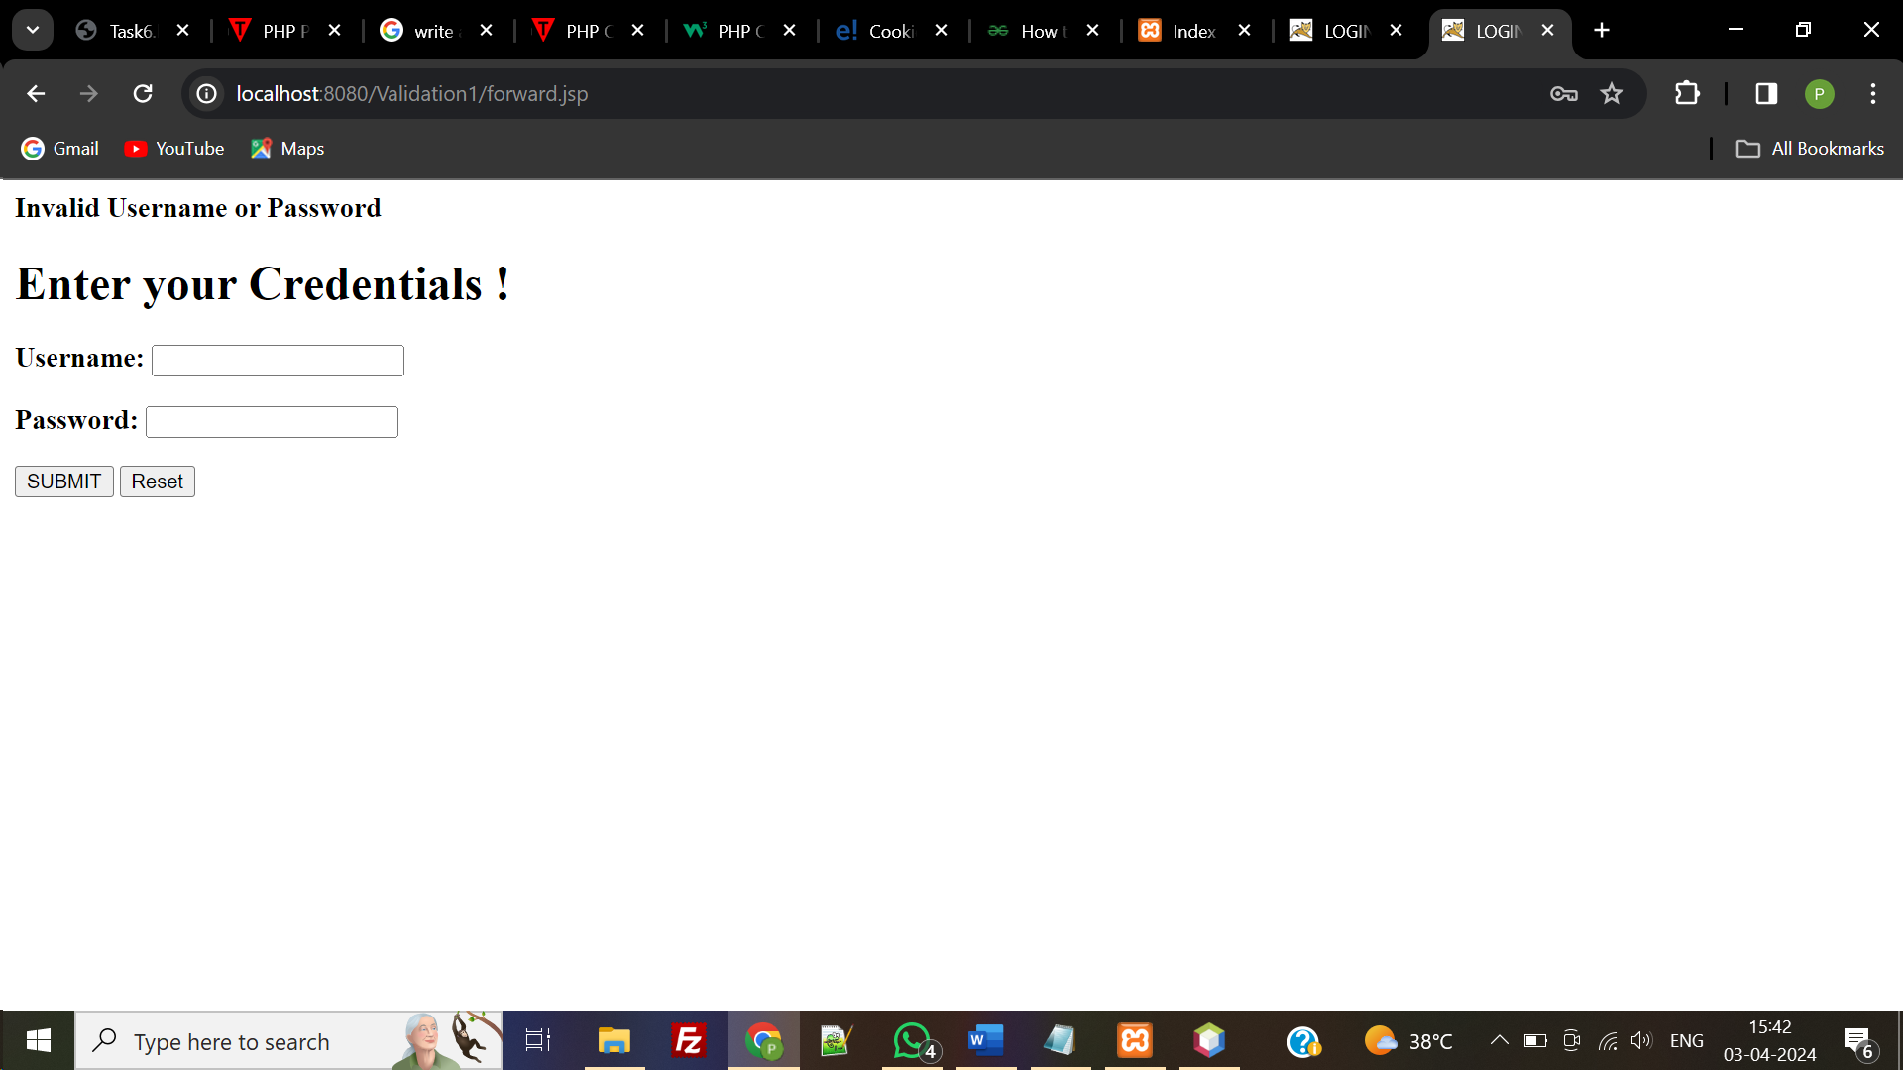

# TASK 10

**TASK 10:** Write PHP programs to do the following tasks:

1. Implement simple calculator operations.
2. Find the transpose of a matrix.
3. Multiplication of two matrices.
4. Addition of two matrices.
5. Develop a PHP program to Implement simple calculator operations.

Program:

<html>

<head>

<style>

table, td, th

{

border: 1px solid black;

width: 35%;

text-align: center;

background-color: lightgreen;

}

table {margin:auto;}

input,p {text-align:right;color:blue;}

</style>

</head>

<body>

<form method="post" action="calculator.php">

<table>

<caption><h2> SIMPLE CALCULATOR </h2></caption>

<tr>

<td>First Number:</td><td><input type="text" name="num1" /></td>

<td rowspan="2"><button type="submit" name="submit" value="calculate">Calculate</td></tr>

<tr>

<td>Second Number:</td><td><input type="text" name="num2"/></td>

</tr>

</form>

<?php

if(isset($_POST['submit'])) // it checks if the input submit is filled

{

$num1 = $_POST['num1'];

$num2 = $_POST['num2'];

if(is_numeric($num1) and is_numeric($num2) )

{

echo "<tr><td> Addition :</td><td><p>".($num1+$num2)."</p></td>";

echo "<tr><td> Subtraction :</td><td><p> ".($num1-$num2)."</p></td>";

echo "<tr><td> Multiplication :</td><td><p>".($num1*$num2)."</p></td>";

echo "<tr><td>Division :</td><td><p> ".($num1/$num2)."</p></td>";

echo "</table>";

}

else

{

echo"<script> alert(' ENTER VALID NUMBER');</script>";

}

}

?>

</body>

</html>

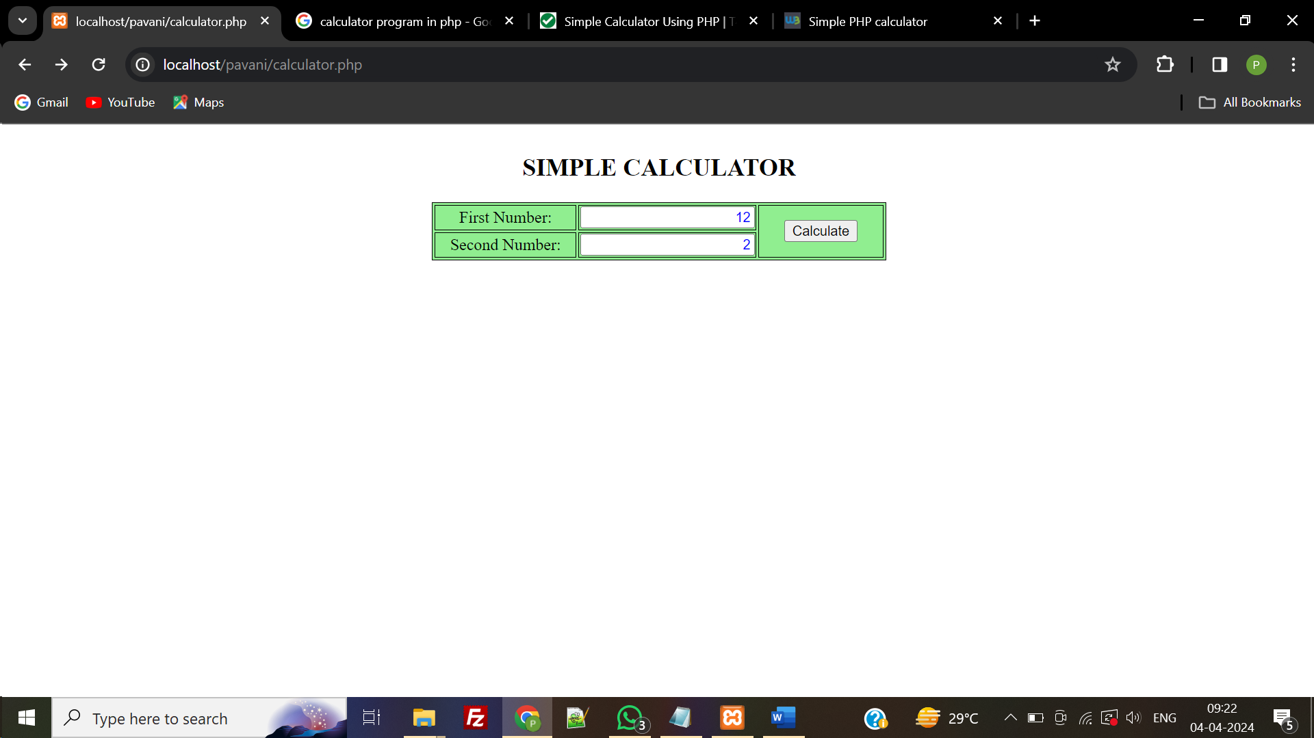

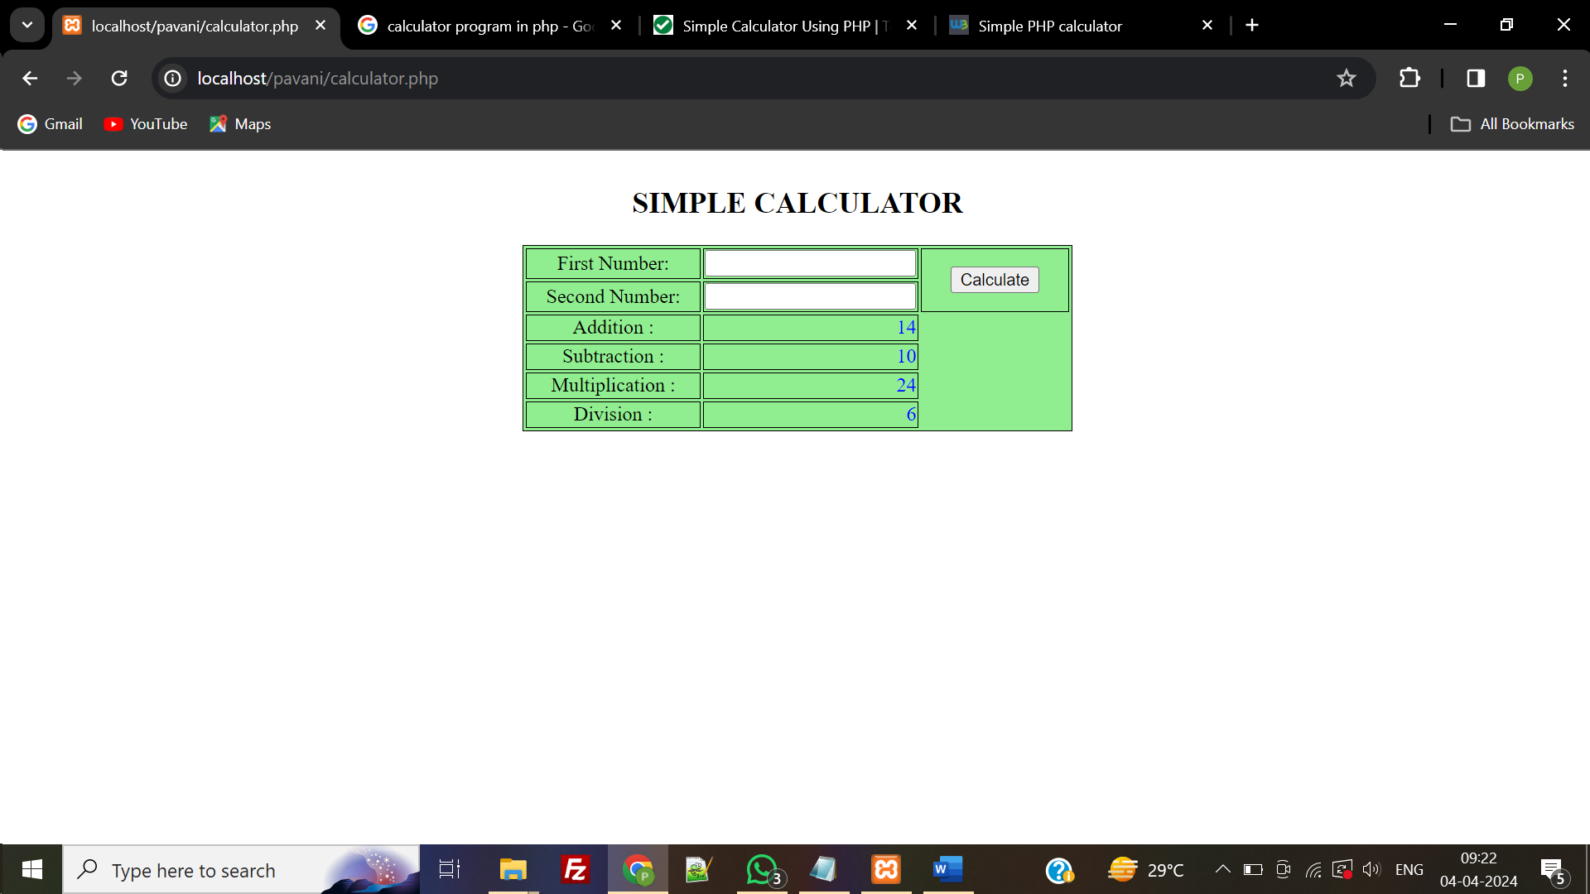

**AIM:** To write PHP program to find transpose, multiplication and addition of two matrices.

**PROGRAM:**

<!DOCTYPE html>

<html>

<body>

<?php

function pr($c){

for($i=0;$i<3;$i++){

for($j=0;$j<3;$j++)

{

echo $c[$i][$j]." ";

}echo "<br>";

}echo "<br>";

}

$a = [[1,1,3],[4,5,6],[7,8,9]];

$b = [[6,8,9],[4,5,6],[4,2,3]];

echo "<b>First Matrix : </b><br>" ; pr($a);

echo "<b>Second Matrix : </b><br>"; pr($b);

for ($i=0; $i < 3; $i++)

for ($j=0; $j < 3; $j++)

$c[$i][$j] = $a[$j][$i];

echo "<b>Transpose Of First Matrix : </b><br>"; pr($c);

for ($i=0; $i < 3; $i++)

for ($j=0; $j < 3; $j++)

$c[$i][$j] = $b[$j][$i];

echo "<b>Transpose Of Second Matrix : </b><br>"; pr($c);

for ($i=0; $i < 3; $i++)

for ($j=0; $j < 3; $j++)

$c[$i][$j] = $a[$i][$j] + $b[$i][$j];

echo "<b>Addition Of Two Matrix : </b><br>"; pr($c);

for ($i=0; $i < 3; $i++)

for ($j=0; $j < 3; $j++){

$c[$i][$j] = 0;

for ($k=0; $k < 3; $k++)

$c[$i][$j] += $a[$i][$k] * $b[$k][$j];

}

echo "<b>Multiplication Of Two Matrix : </b><br>"; pr($c);

?>

</body>

</html>

**OUTPUT:**

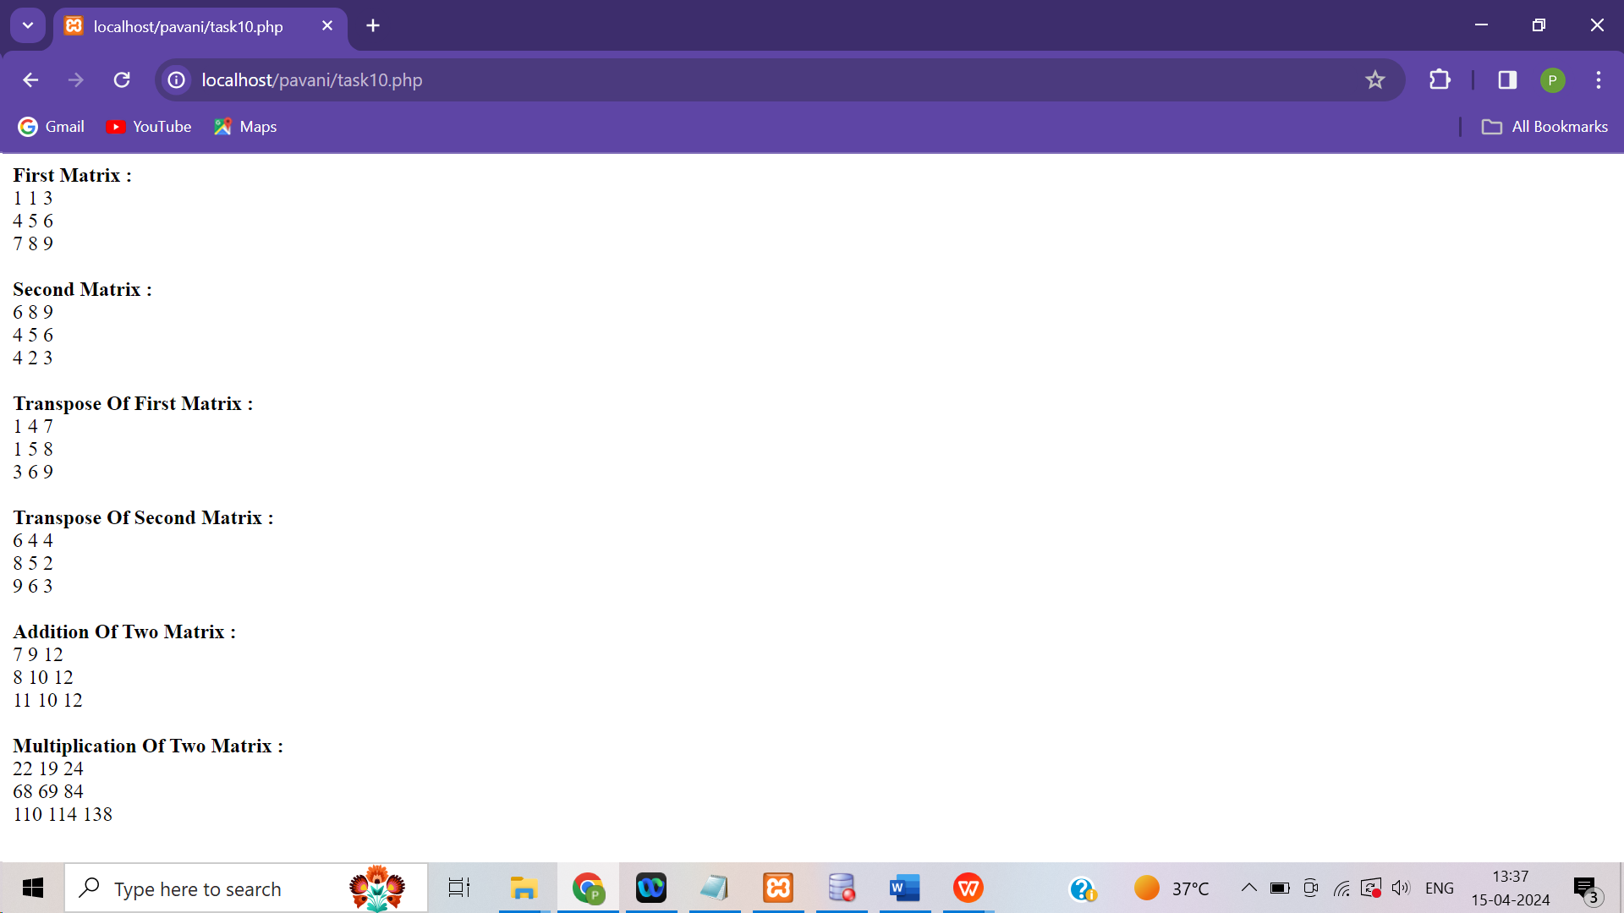

# TASK 11

**TASK 11:** Write a PHP program named states.py that declares a variable states with value "Mississippi Alabama Texas Massachusetts Kansas". Write a PHP program that does the following:

1. Search for a word in variable states that ends in xas. Store this word in element 0 of a list named statesList.
2. Search for a word in states that begins with k and ends in s. Perform a case insensitive comparison.

[Note: Passing re.Ias a second parameter to method compile performs a case-insensitive comparison.] Store this word in element1 of statesList.

1. Search for a word in states that begins with M and ends in s. Store this word in element 2 of the list.
2. Search for a word in states that ends in a. Store this word in element 3 of the list.

**AIM:** To write PHP program to find and store the names of states in elements with variable and perform a case insensitive comparision .

**PROGRAM:**

<html>

<body>

<?php

$states = "Mississippi Alabama Texas Massachusetts Kansas";

$b = explode(' ',$states);

echo "<br>ORIGINAL ARRAY :<br>";

foreach ( $b as $i => $value ) echo "states[$i] = $value<br>"; foreach ($b as $c)

{

$n = strlen($c);

if($c[$n-1]=='s' && $c[$n-2]=='a' && $c[$n-3]=='x') $d[0] = $c; if($c[0]=='K' && $c[$n-1]=='s') $d[1] = $c;

if($c[0]=='M' && $c[$n-1]=='s') $d[2] = $c;

if($c[$n-1]=='a') $d[3] = $c;

}

echo "<br>RESULTANT ARRAY :<br>";

for ($i=0; $i < count($d); $i++) echo "statesList[$i] = $d[$i]<br>";

?>

</body>

</html>

**OUTPUT:**

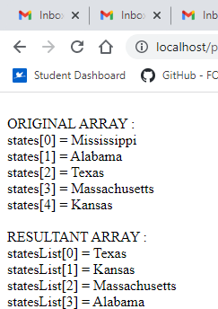

# TASK 12

**TASK 12:** Write a PHP program to sort the student records which are stored in the database using selection sort.

**AIM:** To write PHP program to sort student records in the database using selection sort.

**PROGRAM:**

<!DOCTYPE html>

<html>

<head>

</head>

<body>

<?php

$domain = "localhost";

$username = "root";

$password = "";

$dbname = "student";

$a = [];

$conn = mysqli_connect($domain, $username, $password, $dbname); if ($conn->connect_error)

die("Connection failed: " . $conn->connect_error);

$sql = "SELECT * FROM studentinfo";

$result = $conn->query($sql); echo "<br>";

echo "<h2>BEFORE SORTING</h2>";

echo "<table border='2'>"; echo "<tr>";

echo "<th>USN</th><th>Name</th><th>Address</th></tr>"; if ($result->num_rows > 0) {

while ($row = $result->fetch_assoc()) { echo "<tr>";

echo "<td>" . $row["usn"] . "</td>";

echo "<td>" . $row["name"] . "</td>";

echo "<td>" . $row["address"] . "</td></tr>"; array_push($a, $row["usn"]);

}

} else

echo "Table is Empty"; echo "</table>";

$n = count($a);

for ($i = 0; $i < ($n - 1); $i++) {

$pos = $i;

for ($j = $i + 1; $j < $n; $j++) { if ($a[$pos] > $a[$j])

$pos = $j;

}

if ($pos != $i) {

$temp = $a[$i];

$a[$i] = $a[$pos];

$a[$pos] = $temp;

}

}

$c = [];

$d = [];

$result = $conn->query($sql); if ($result->num_rows > 0) {

while ($row = $result->fetch_assoc()) { for ($i = 0; $i < $n; $i++) {

if ($row["usn"] == $a[$i]) {

$c[$i] = $row["name"];

$d[$i] = $row["address"];

}

}

}

}

echo "<br>";

echo "<h2>AFTER SORTING</h2>";

echo "<table border='2'>"; echo "<tr>";

echo "<th>USN</th><th>NAME</th><th>Address</th></tr>"; for ($i = 0; $i < $n; $i++) {

echo "<tr>";

echo "<td>" . $a[$i] . "</td>";

echo "<td>" . $c[$i] . "</td>"; echo "<td>" . $d[$i] . "</td></tr>";

}

echo "</table>";

$conn->close();

?>

</body>

</html>

**OUTPUT:**

